West Side Gymnastics School
3rd Annual Flip Flop Invitational
USAIGC March 14th

USAIGC-State Qualifier (States Will Be At West Side)
Entry Fee-$85.00
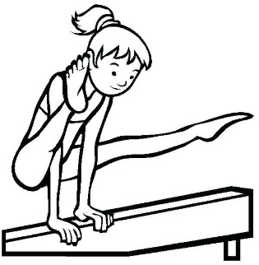
(Checks made out to George Sabotka/West Side)
Free T-Shirt with Entry. Add Gymnasts T-shirt size to entry
Team Entry Fee Per Level-$40.00
All teams who enter will receive a banner. 3 gymnast’s count.
Entry Deadline February 14th.
Sessions will be announced on March 1st or sooner.

Send Entry To,
West Side Gymnastics School
923 West Genesee Street,
Syracuse, NY 13204
Telephone Number
315-423-6598
Email-wsbackflip2@aol.com
Your entry will be confirmed with payment.



