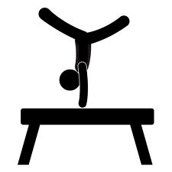West Side Gymnastics School

Price List For Summer Gymnastics

315-423-6598

Preschool

$82 for 4 classes (One Month) Pick July or August

$143 for 6 classes (One Month- 2 Times a Week)

$165 for 9 classes (One Month Unlimited) Pick July Or August

$185 for 12classes (One Month Plus One Week)

$230 for 15 classes (One Month Plus Two Weeks)

$250 For 18 Classes (Two Full Months Unlimited)

Boys- Ninja/Gymnastics Classes

$82 for 4 classes (Once a Week)

$143 for 6 classes (One Month Unlimited)

$165 for 8 classes (One Month Plus 1 Week)

$184 for 10 classes (One Month Plus 2 Weeks)

$200 for 12 classes (Two Full Months-Unlimited)

Beginner Girls And Advanced Girls

$92.00 for 4 Classes (One Month-One Day A Week)

$161 for 6 Classes (One Month-Two Days a Week)

$185 for 9 Classes (One Month Unlimited-3 Classes per Week)

$225 for 12 classes (One Month Unlimited Plus One Week)

$250 for 15 Classes (One Month Unlimited Plus Two Weeks)

$280 for 18 Classes (Two Months Unlimited) Come to as many as you want.

Tumbling And Trampoline Class

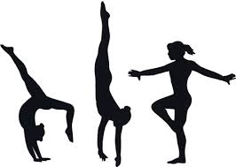$82.00 for 4 classes (One Month- One Day a Week)

$143 for 6 classes ( One Month Unlimited)

$165 for 8 classes (One Month Plus One Week)

$184 for 10 classes (One Month Plus Two Weeks)

$200 for 12 classes ( Two Months Unlimited)

The best deal, as you can see, is the TWO MONTH UNLIMITED PROGRAM You can come to all the classes of your level throughout the whole summer. The savings here is at least 25-35%. We offer enough possibilities so that you can find what works best for you and your family. Have a great summer!