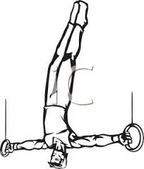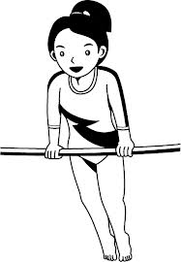West Side Gymnastics School

Summer Application 2025

**Summer Classes Start July 7th**

**315-423-6598**

**___________________________________________________________________________________**

**SUMMER APPLICATION**

Name_____________________________ Age________Class Level____________

4 Classes____6 Classes___ 9 Classes____12 Classes____15 Classes_Unlimited 18 Classes___

The classes can be taken in July and or August depending on how many classes you take.

**There are 9 classes per month except for Ninja Boys who have 6 per month.**

**Unlimited means you can take one level of unlimited classes.**

**This will be based on the level that you are.**

**The best deal is the Unlimited deal.**

**Come to as many classes of your level that you want to.**

**All Summer Long!**

I give permission for my child to take gymnastics at West Side Gymnastics School for summer classes. I understand that participating in any sport poses inherent risks. I further understand that West Side will adhere to the gymnastic industry safety standards. I will not hold West Side, it's instructors, and owners liable for any injuries or mishaps that might occur.

Parent or Guardians signature______________________________Date______

Address__________________________City________ NY Zip Code_________

Contact information Mom or Dads Cell phone____________

Other contact_____________

Email______________________________